

**A Project Report On**

AUTOMATION TESTING ON YOUR STORE DEMO

WEBSITE

**By**

**Jannat Shaikh**

**Batch: (2021-5765)**

**Course: S Prayas Certified Software Test Engineer**

**Under the Guidance of**

**Priyanka Desale**

**( Edubridge Technical Trainer )**

**INTRODUCTION**

This Project aims to do overall testing like functional testing, GUI testing on website to check quality of application. It helps to improve quality of website and saves time for manually doing this testing. In this project our main focus is to check functionalities available on website. Also, it includes title check and all links count with their working status.

**SOFTWARE REQUIREMENTS**

* Operating System: Windows 10
* Browser: Latest version of Chrome
* IDE: Eclipse IDE
* Automation Tool: Selenium WebDriver
* Front-end: Java

**TC01 – TO LAUNCH BROWSER AND OPEN URL**

*System.setProperty("webdriver.chrome.driver", "D:\selenium jar\chromedriver.exe");*‬

*WebDriver w=new ChromeDriver(); w.get("http://tutorialsninja.com/demo/index.php?route=common/home”);*

*w.manage().window().maximize();*

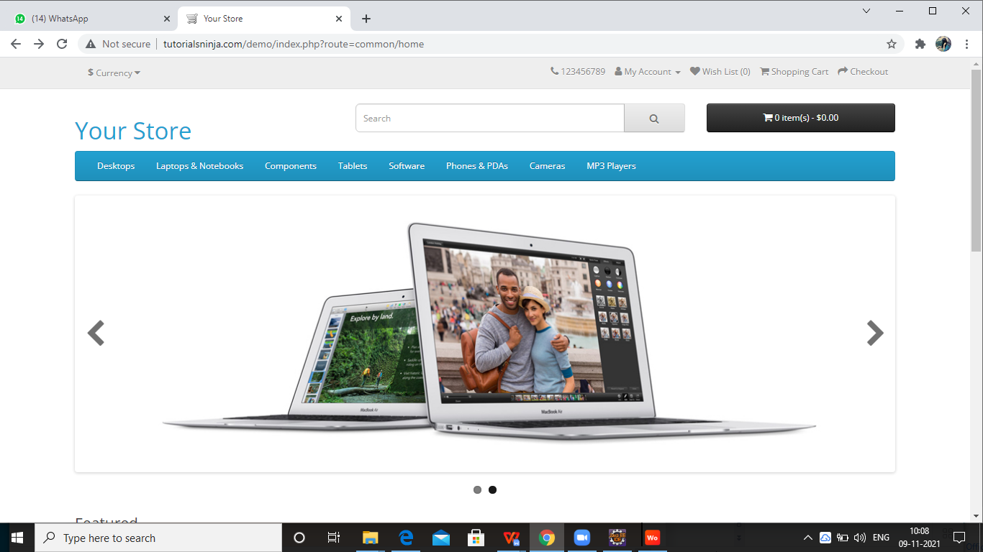

**TC02 – REGISTRATION AND LOGIN FOR YOUR STORE DEMO WEBSITE**

REGISTRATION :-

w.findElement(By.xpath("//*[@id=\"top-links\"]/ul/li[2]/a")).click();

w.findElement(By.linkText("Register")).click();

w.findElement(By.name("firstname")).sendKeys("Darshu");

w.findElement(By.name("lastname")).sendKeys("paniya");

w.findElement(By.name("email")).sendKeys("dpaniya@gmail.com");

w.findElement(By.name("telephone")).sendKeys("9874561230");

w.findElement(By.name("password")).sendKeys("123456");

w.findElement(By.name("confirm")).sendKeys("123456");

w.findElement(By.name("newsletter")).click();

w.findElement(By.name("agree")).click();

w.findElement(By.xpath("//*[@id=\"content\"]/form/div/div/input[2]")).click();

w.findElement(By.xpath("//*[@id=\"content\"]/div/div/a")).click();

LOGIN:-

w.findElement(By.*xpath*("//*[@id=\"top-links\"]/ul/li[2]/a")).click();

w.findElement(By.*linkText*("Login")).click();

w.findElement(By.*name*("email")).sendKeys("dpaniya@gmail.com");

w.findElement(By.*name*("password")).sendKeys("123456");

w.findElement(By.*xpath*("//*[@id=\"content\"]/div/div[2]/div/form/input")).click();

**TCO3- TO CHECK SOFTWARE FUNCTIONALITY OF WEBSITE**

w.findElement(By.*linkText*("Software")).click();

TakesScreenshot t=(TakesScreenshot) w;

File src=t.getScreenshotAs(OutputType.***FILE***);

Files.*copy*(src, **new** File("C:\\Users\\DARSHANA\\Desktop\\s2.png"));

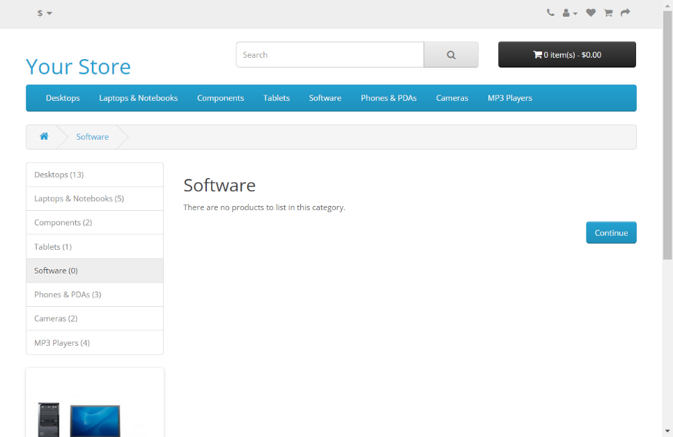

**TC04- TO CHECK PHONE & PDAs FUNCTIONALITY OF WEBSITE**

w.findElement(By.*linkText*("Phones & PDAs")).click();

w.findElement(By.*id*("list-view")).click();

w.findElement(By.*id*("grid-view")).click();

Select s= **new** Select(w.findElement(By.*id*("input-sort")));

s.selectByValue("http://tutorialsninja.com/demo/index.php?route=product/category&path=24&sort=p.price&order=DESC");

w.findElement(By.*xpath*("//*[@id=\"content\"]/div[2]/div[1]/div/div[2]/div[2]/button[2]")).click();

**TC05- WISHLIST FUNCTIONALITY**

w.findElement(By.*xpath*("//*[@id=\"wishlist-total\"]")).click();

TC06- TO CHECK CAMERA FUNCTIONALITY OF SOFTWARE

w.findElement(By.*linkText*("Cameras")).click();

w.findElement(By.*xpath*("//*[@id=\"content\"]/div[2]/div[1]/div/div[1]/a/img")).click();

w.findElement(By.*xpath*("//*[@id=\"content\"]/div/div[2]/div[1]/button[2]")).click();

w.navigate().back();

w.findElement(By.*linkText*("Product Compare (0)")).click();

Select s=**new** Select(w.findElement(By.*id*("input-option226")));

TakesScreenshot t=(TakesScreenshot) w;

File src=t.getScreenshotAs(OutputType.***FILE***);

Files.*copy*(src, **new** File("C:\\Users\\DARSHANA\\Desktop\\s.png"));

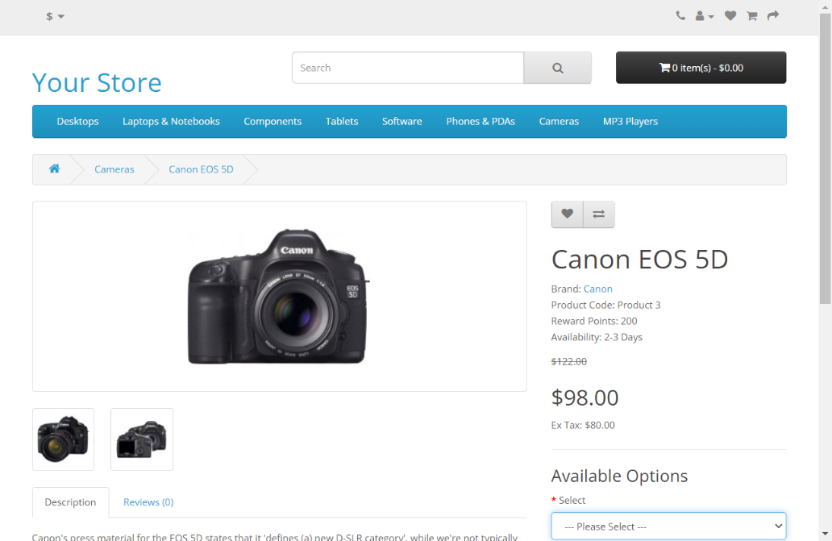

**TC07- TO CHECK MX PLAYER FUNCTIONALITY OF WEBSITE**

Actions a =**new** Actions(w);

a.moveToElement(w.findElement(By.*linkText*("MP3 Players"))).build().perform();

w.manage().timeouts().implicitlyWait(5,TimeUnit.***SECONDS***);

w.findElement(By.*linkText*("test 24 (0)")).click();

**TC08:- TO CHECK CURRENCY FUNCTIONALITY FOR EURO CURRENCY:-**

System.*setProperty*("webdriver.chrome.driver",

"C:\\Users\\JANNAT\\Desktop\\SELENIUM\\chromedriver.exe");

WebDriver w=**new** ChromeDriver();

w.get("http://tutorialsninja.com/demo");

w.manage().window().maximize();

//EUR OPTION:-

w.findElement(By.*xpath*("//*[@id=\"form-currency\"]/div/button”)).click();

w.findElement(By.*name*("EUR")).click();

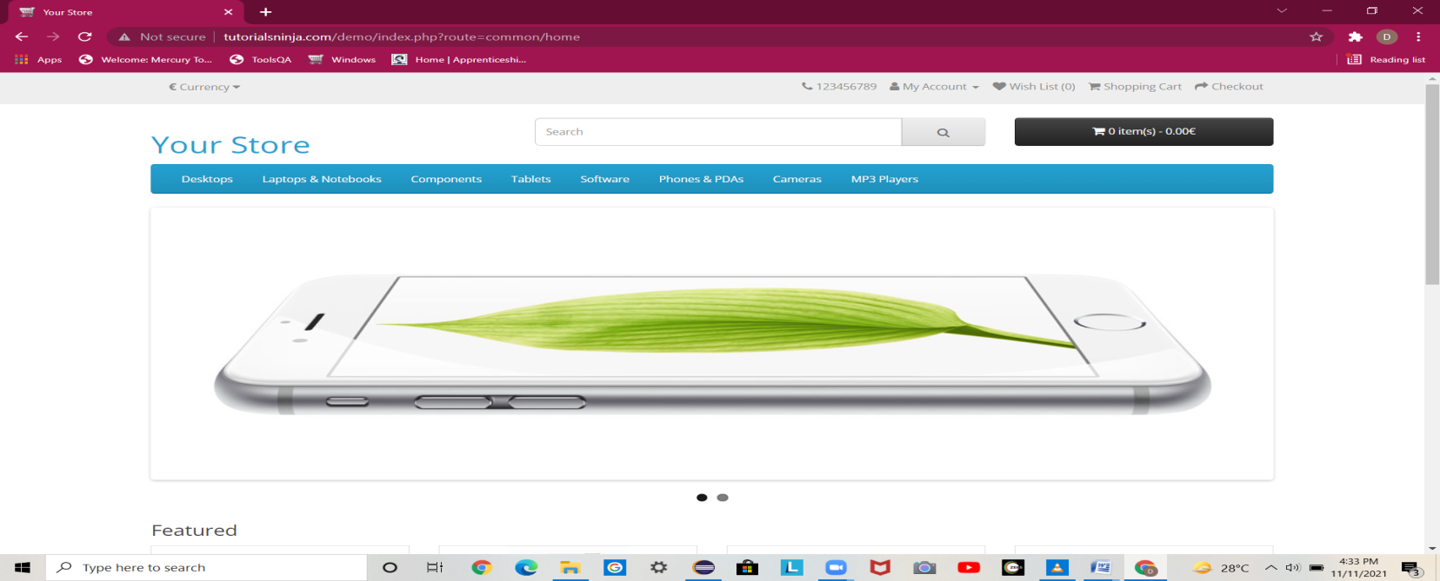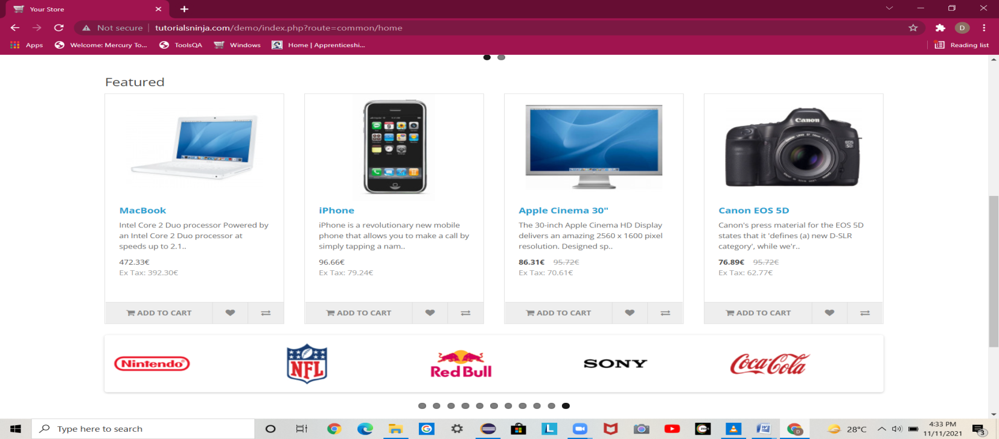

**TC9:-- TO CHECK FUNCTIONALITY OF CURRENCY BUTTON FOR POUND STERLING CURRENCY:-**

System.*setProperty*("webdriver.chrome.driver", "C:\\Users\\JANNAT\\Desktop\\SELENIUM\\chromedriver.exe");

WebDriver w=**new** ChromeDriver();

w.get("http://tutorialsninja.com/demo");

w.manage().window().maximize();

//POUND STERLING OPTION:-

Select s1=**new** Select(w.findElement(By.*name*("GBP")));

s1.selectByVisibleText("£ Pound Sterling");

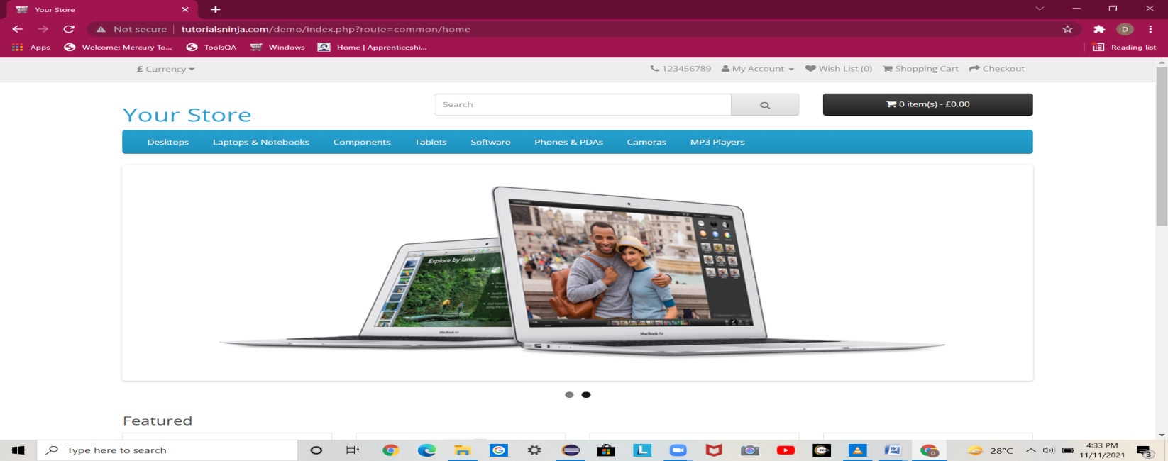

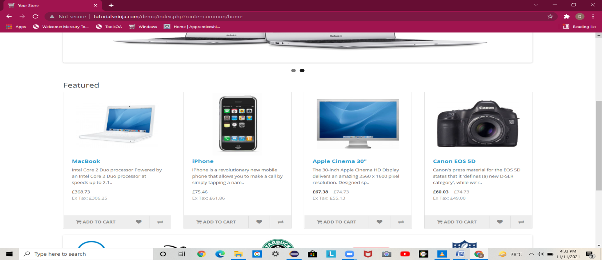

***TC10:--- TO CHECK CURRENCY FUNCTIONALITY WITH US DOLLAR CURRENCY:-***

System.*setProperty*("webdriver.chrome.driver", "C:\\Users\\JANNAT\\Desktop\\SELENIUM\\chromedriver.exe");

WebDriver w=**new** ChromeDriver();

w.get("http://tutorialsninja.com/demo");

w.manage().window().maximize();

//DOLLAR OPTION:-

Select s2=**new** Select(w.findElement(By.*name*("USD")));

s2.selectByVisibleText("$ US Dollar");

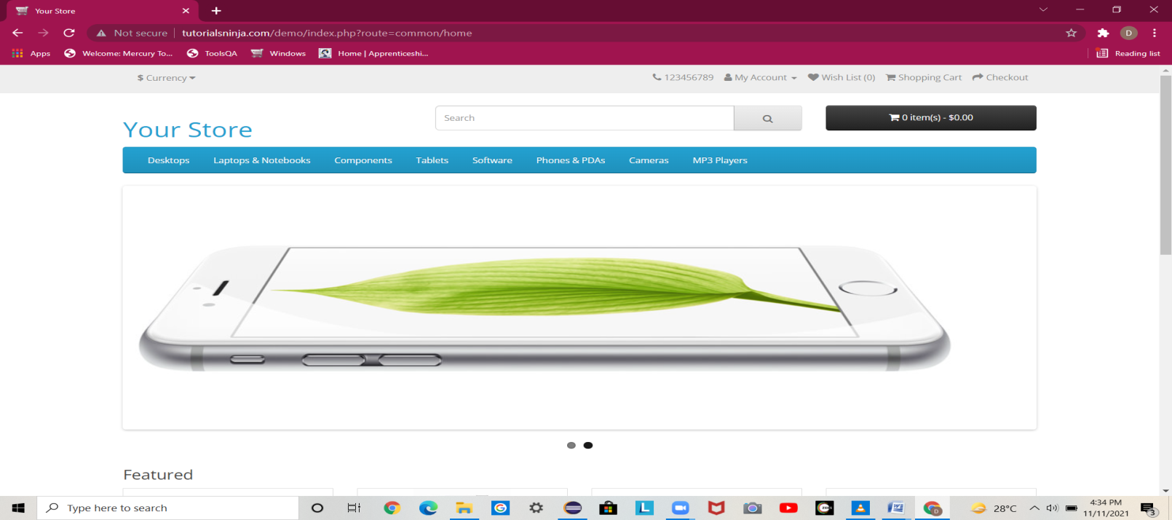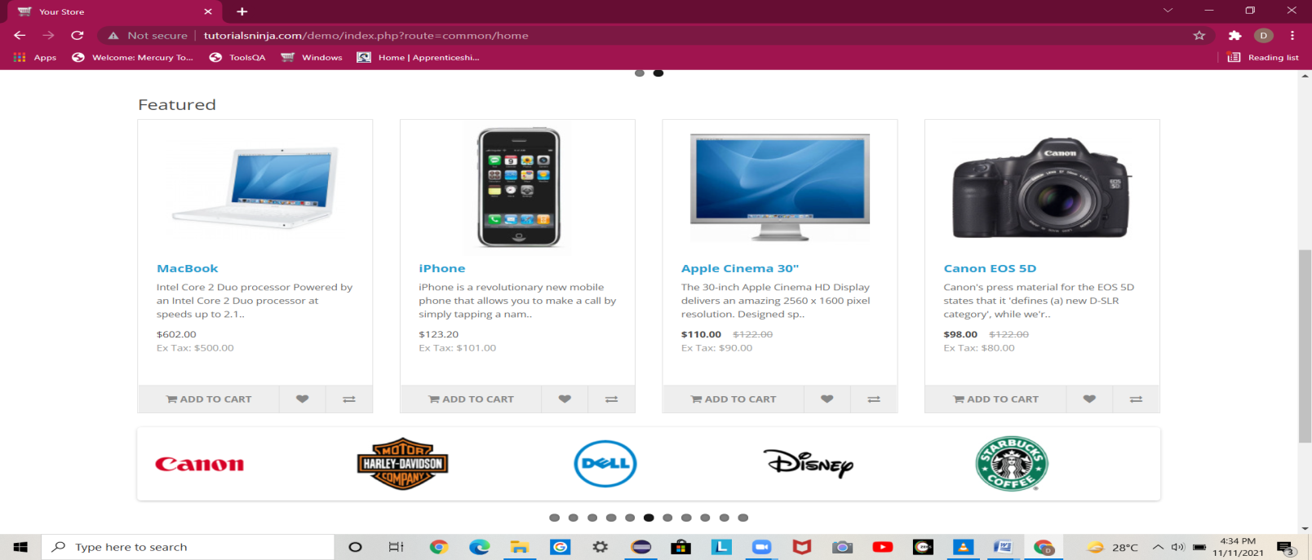

**TC11:- TO CHECK FUNCTIONALITY OF CONTACT US BUTTON OF HOME PAGE**

w.findElement(By.xpath("//*[@id=\”top-links\”]/ul/li[1]")).click();

Thread.sleep(2000)

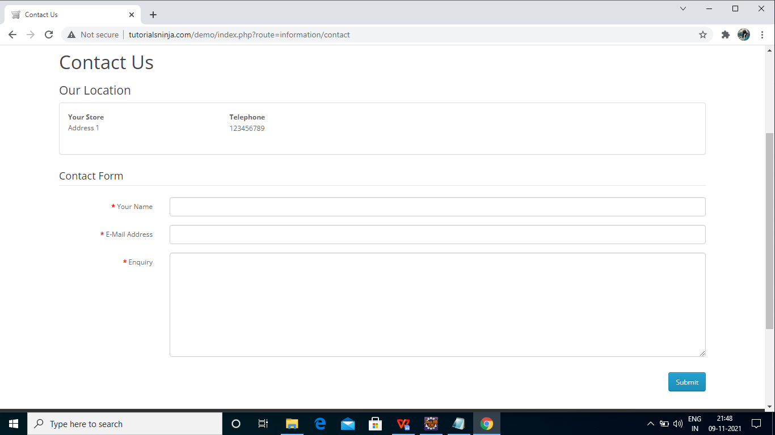

# 

**TC12- TO CHECK FUNCTIONALITY OF SUBMIT BUTTON OF CONTACT PAGE**

w.findElement(By.id("input-name")).sendKeys("abc");

w.findElement(By.id("input-email")).sendKeys("abc@gmail.com");

w.findElement(By.id("input-enquiry")).sendKeys("abcdef123456");

w.findElement(By.xpath("//*[@id=\"content\"]/form/div/div/input")).click();

Thread.sleep(2000);

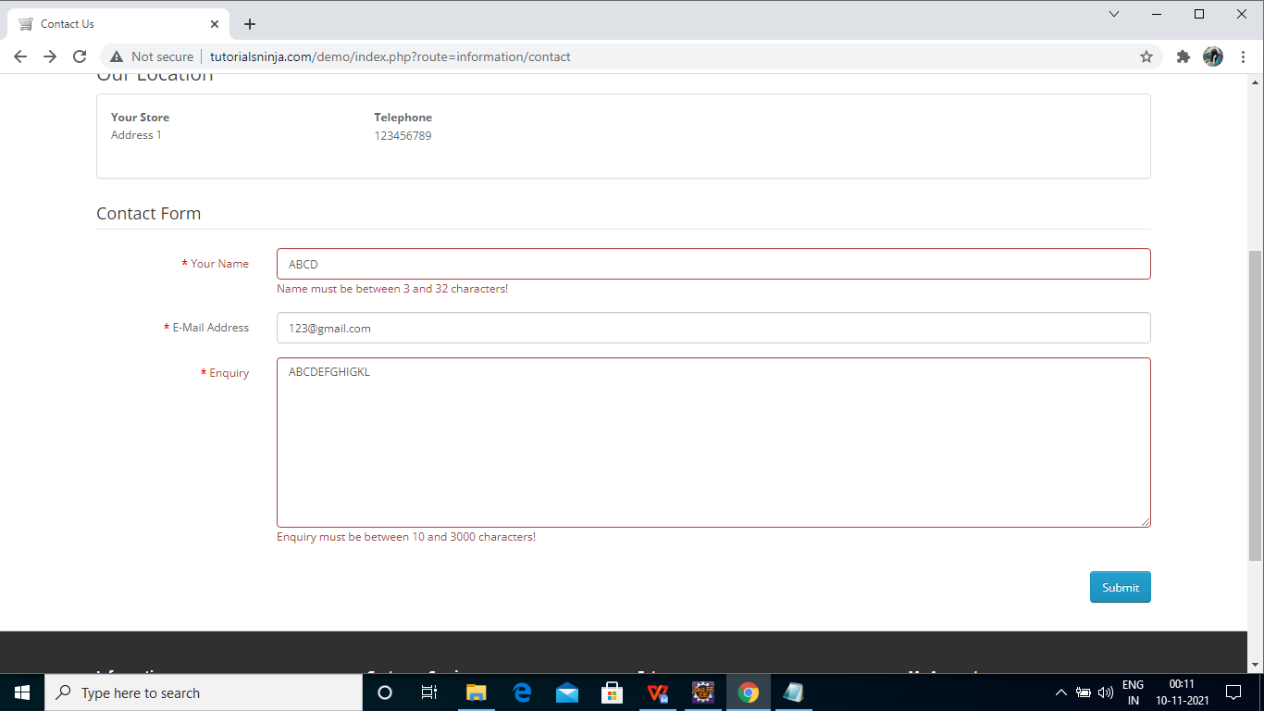

**TC13- TO CHECK THE FUNCTIONALITY OF CONTINUE BUTTON OF CONTACT PAGE**

*w.findElement(By.xpath("//*[@id=\"content\"]/div/div/a")).click();*

Thread.sleep(2000);

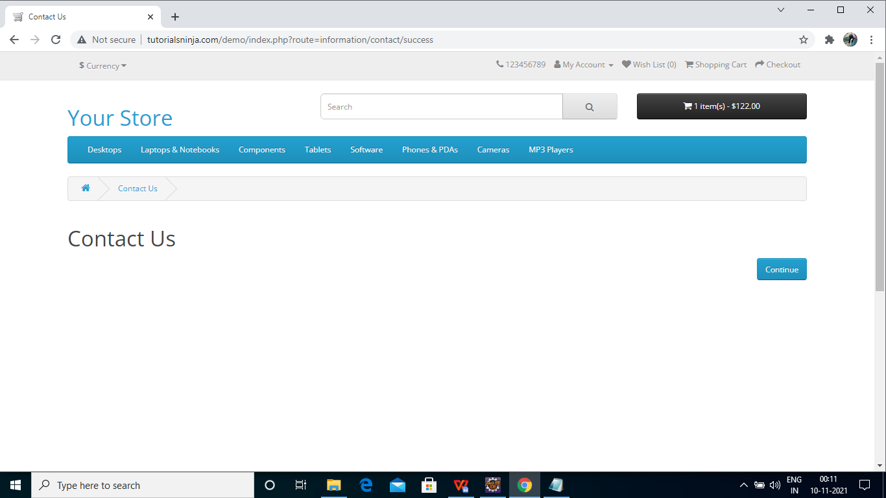

**TC14- TO CHECK THE FUNCTIONALITY OF SEARCH BAR OF HOME PAGE**

*w.findElement(By.name("search")).sendKeys("Tablets");*

*w.findElement(By.xpath("/html/body/header/div/div/div[2]/div/span/button")).click();*

Thread.sleep(2000);

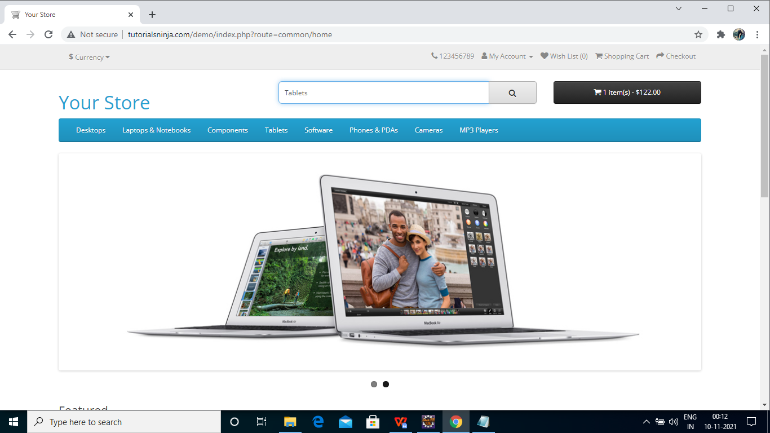

**TC15- TO CHECK THE FUNCTIONALITY OF DESKTOP PAGE:-**

w.findElement(By.*linkText*("Desktops")).click();

w.findElement(By.*xpath*("//*[@id=\"menu\"]/div[2]/ul/li[1]/a")).click();

w.findElement(By.*id*("list-view")).click();

Select s1=**new** Select(w.findElement(By.*xpath*("//*[@id=\\\"menu\\\"]/div[2]/ul/li[1]/div/div/ul/li[1]/a")));

s1.selectByVisibleText("PC (0)");

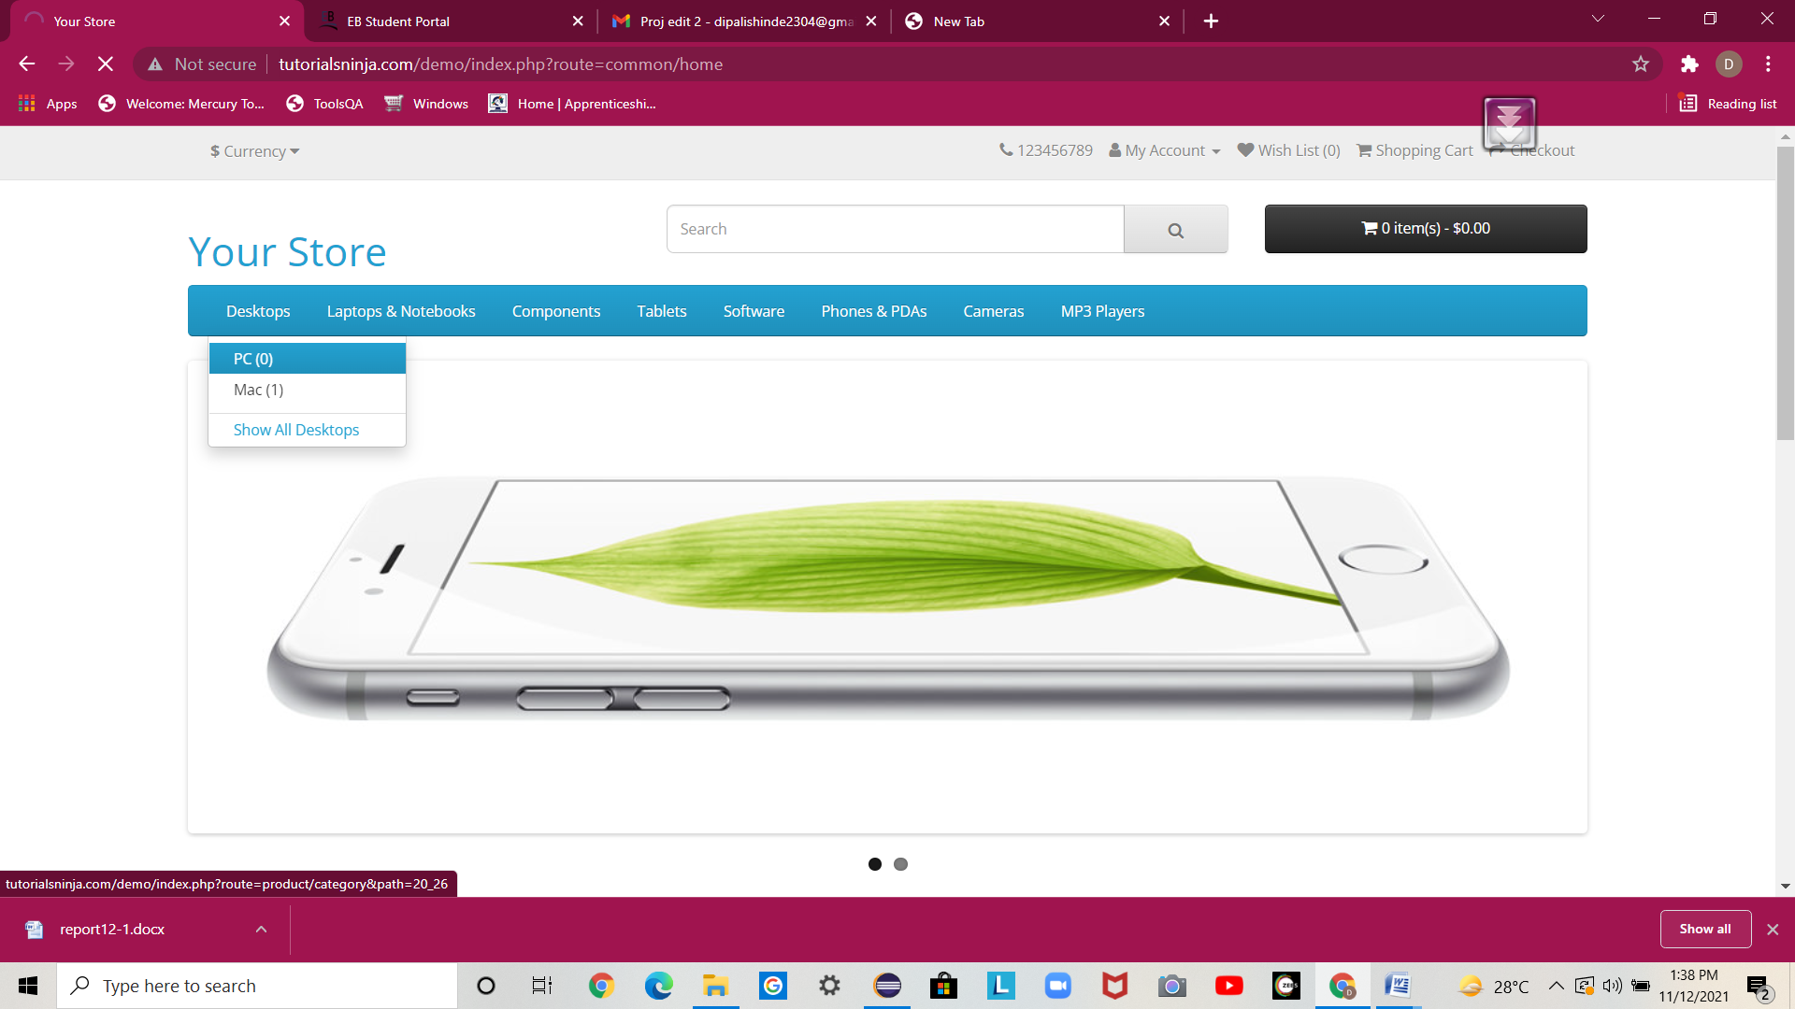

**TC16- TO CHECK THE FUNCTIONALITY OF DESKTOP PAGE PC OPTION:-**

Select s1= **new** Select(w.findElement(By.*xpath*("//*[@id=\\\"menu\\\"]/div[2]/ul/li[1]/div/div/ul/li[1]/a")));

s1.selectByVisibleText("PC (0)");

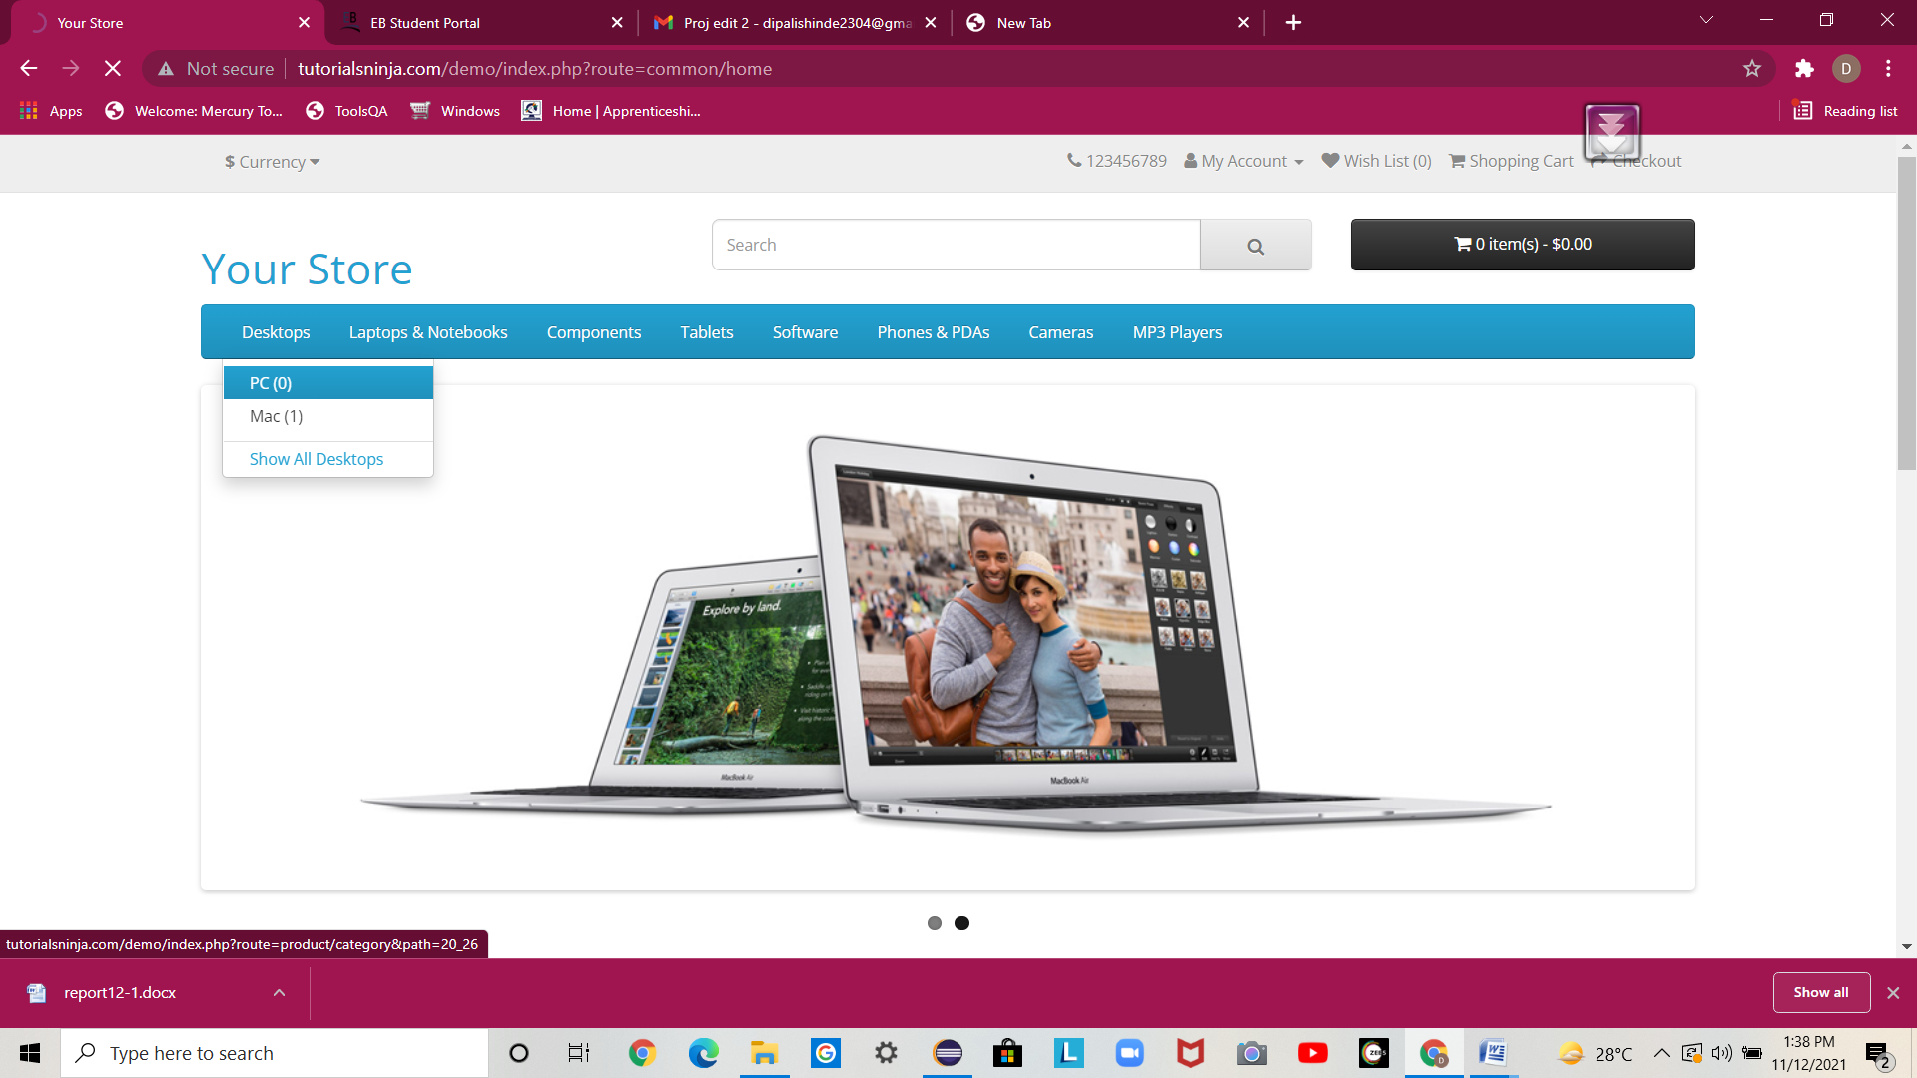

**TC17:- TO CHECK THE FUNCTIONALITY OF DESKTOP PAGE PC OPTION CONTINUE BUTTON:-**

w.findElement(By.*linkText*("Continue")).click(); w.findElement(By.*xpath*("//*[@id=\"content\"]/div/div/a")).click();

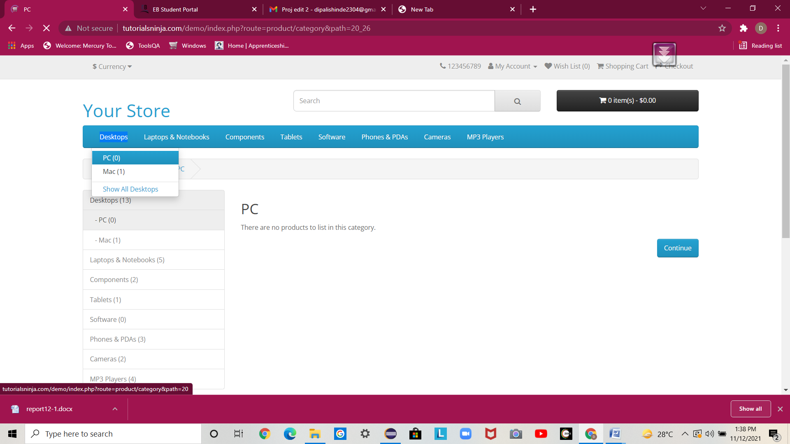

**TC18:- TO CHECK THE FUNCTIONALITY OF DESKTOP PAGE MAC OPTION:-**

Select s2=**new** Select(w.findElement(By.*xpath*("//*[@id=\"menu\"]/div[2]/ul/li[1]/div/div/ul/li[2]/a")));

s2.selectByVisibleText("Mac (1)");

w.findElement(By.*xpath*("//*[@id=\"menu\"]/div[2]/ul/li[1]/div/div/ul/li[2]/a")).click();

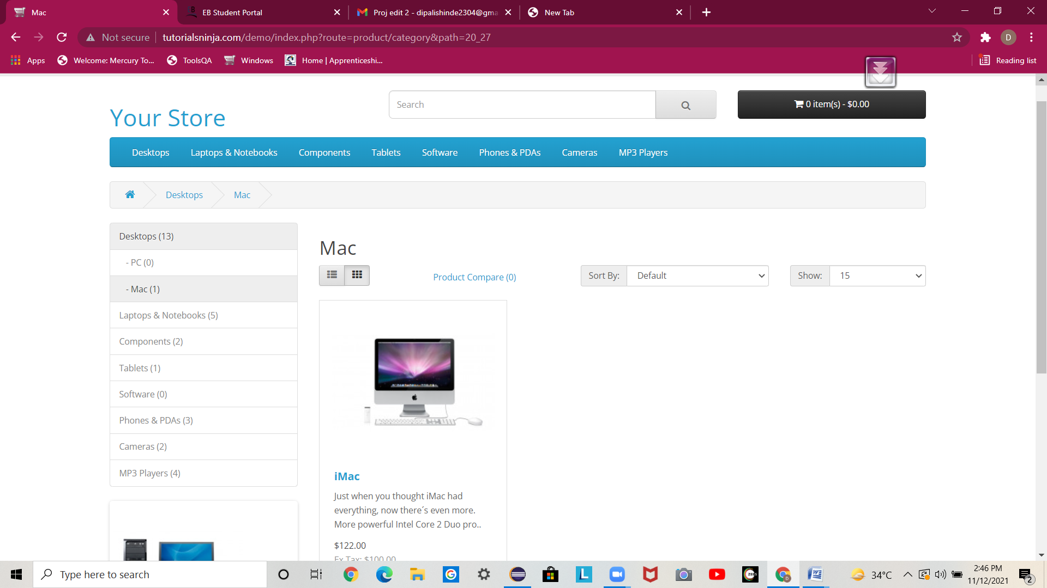

**TC19:- TO CHECK THE FUNCTIONALITY OF LAPTOPS AND NOTEBOOKS OPTION:-**

System.*setProperty*("webdriver.chrome.driver", "C:\\Users\\JANNAT\\Desktop\\SELENIUM\\chromedriver.exe");

WebDriver w=new ChromeDriver();

w.get("http://tutorialsninja.com/demo");

w.manage().window().maximize();

w.findElement(By.*linkText*("Laptops & Notebooks")).click();

w.findElement(By.*className*("dropdown open")).click();

w.findElement(By.*id*("list-view")).click();

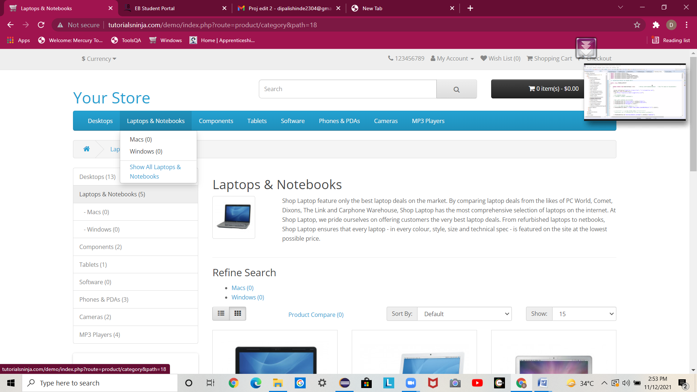

**TC20:- :- TO CHECK THE FUNCTIONALITY OF LAPTOPS AND NOTEBOOKS IN MAC OPTION:-**

Select s1=new Select(w.findElement(By.xpath("//*[@id=\"column-left\"]/div[1]/a[3]")));

s1.selectByVisibleText("Macs (0)");

w.findElement(By.xpath("//*[@id=\"content\"]/div/div/a")).click();

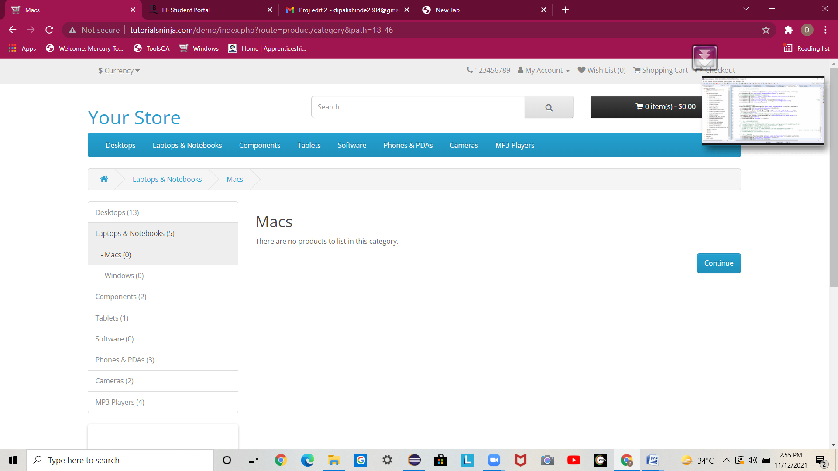

**TC21:- TO CHECK THE FUNCTIONALITY OF LAPTOPS AND NOTEBOOKS IN WINDOWS OPTION:-**

w.findElement(By.*linkText*("Windows (0)")).click();

// w.findElement(By.className("dropdown open")).click();

w.findElement(By.*xpath*("//*[@id=\"column-left\"]/div[1]/a[4]")).click();

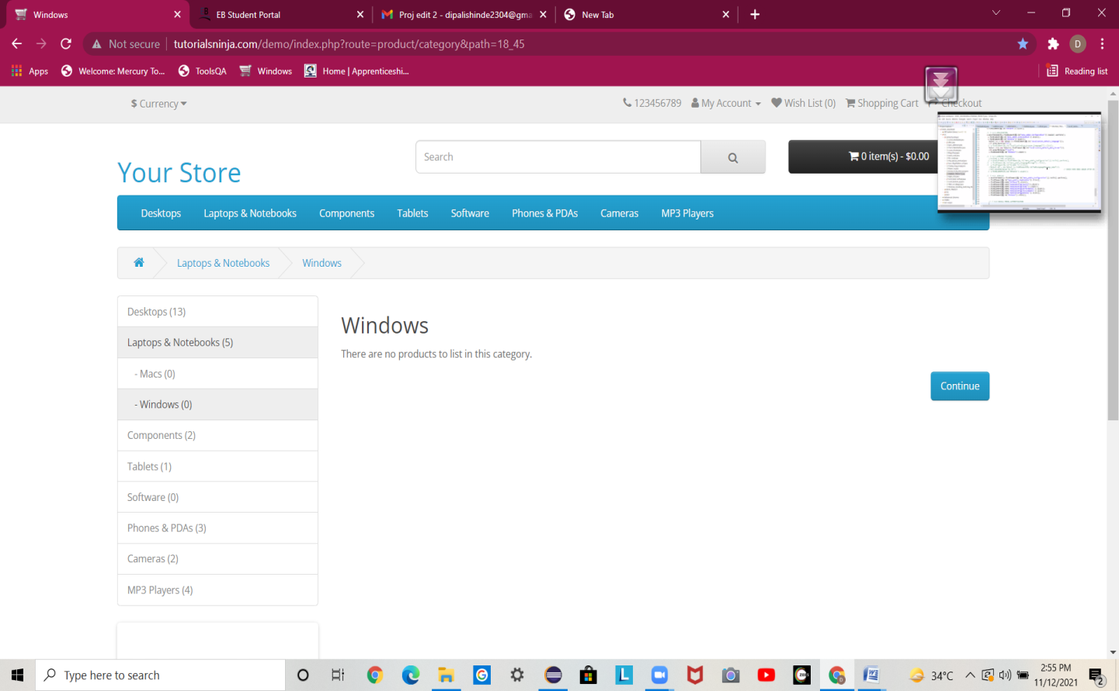

**TC22:- TO CHECK THE FUNCTIONALITY OF SEARCH BUTTON FOR COMPONENTS OPTION:-**

System.*setProperty*("webdriver.chrome.driver", "C:\\Users\\JANNAT\\Desktop\\SELENIUM\\chromedriver.exe");

WebDriver w=**new** ChromeDriver();

w.get("http://tutorialsninja.com/demo");

w.manage().window().maximize();

w.findElement(By.*linkText*("Components")).click();

w.findElement(By.*xpath*("//*[@id=\"menu\"]/div[2]/ul/li[3]/a")).click();

w.findElement(By.*id*("list-view")).click();

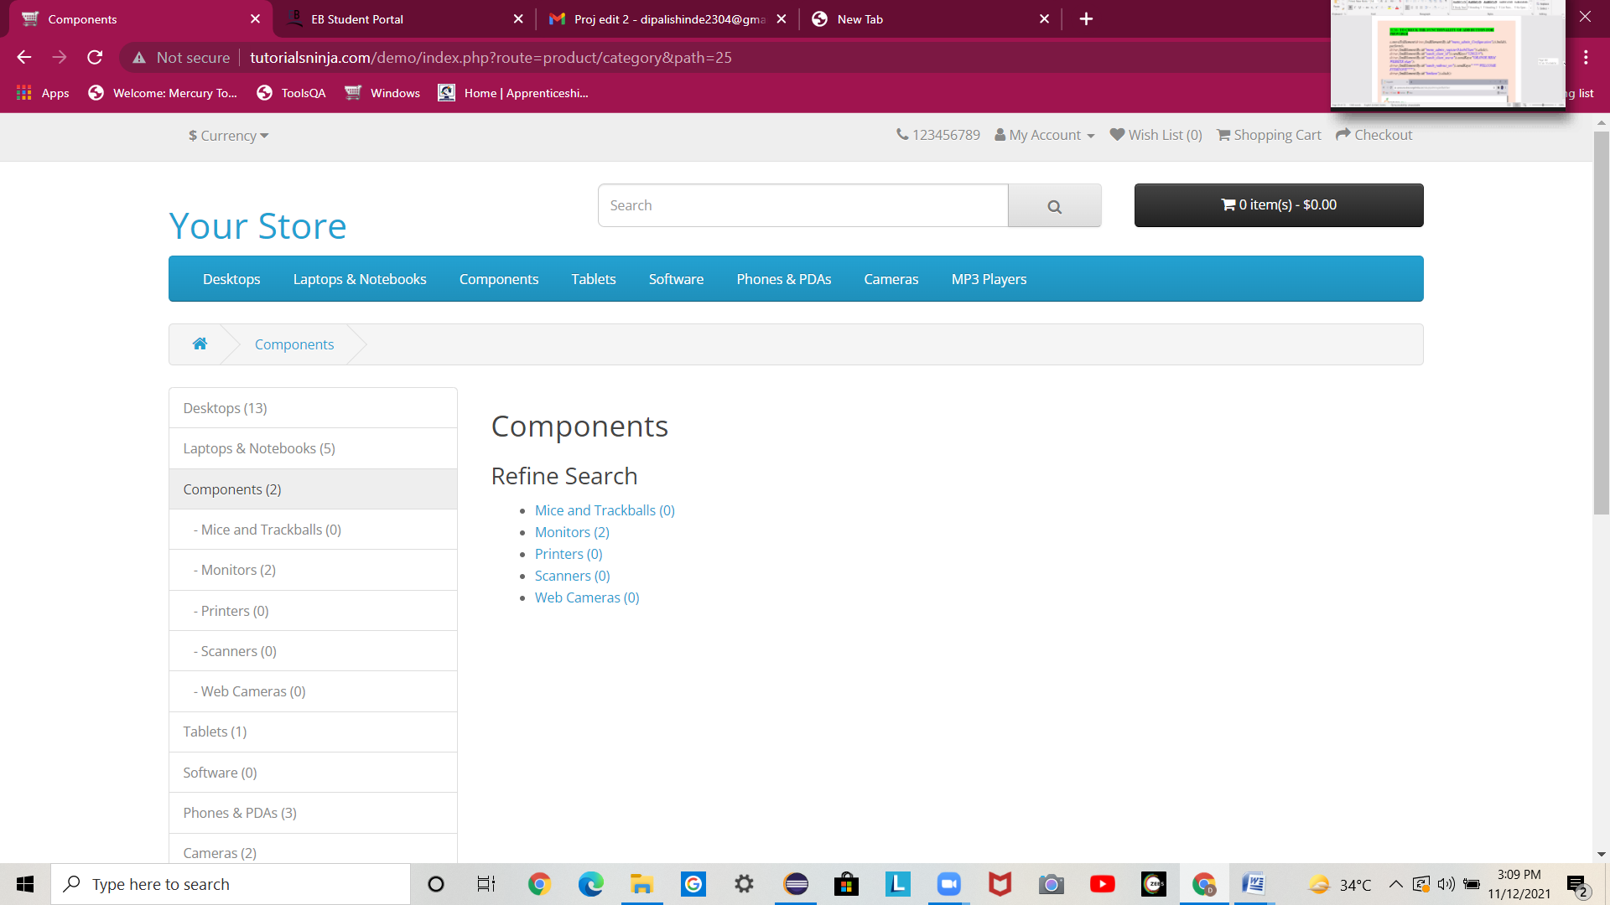

**TC23:- TO CHECK THE FUNCTIONALITY OF SEARCH BUTTON FOR COMPONENTS MAC AND TRACKBALL OPTION:-**

// MICE AND TRACKBALLS:-

w.findElement(By.*linkText*("Mice and Trackballs (0)")).click();

// w.findElement(By.className("dropdown open")).click();

w.findElement(By.xpath("//*[@id=\"menu\"]/div[2]/ul/li[3]/div/div/ul/li[1]/a")).click();

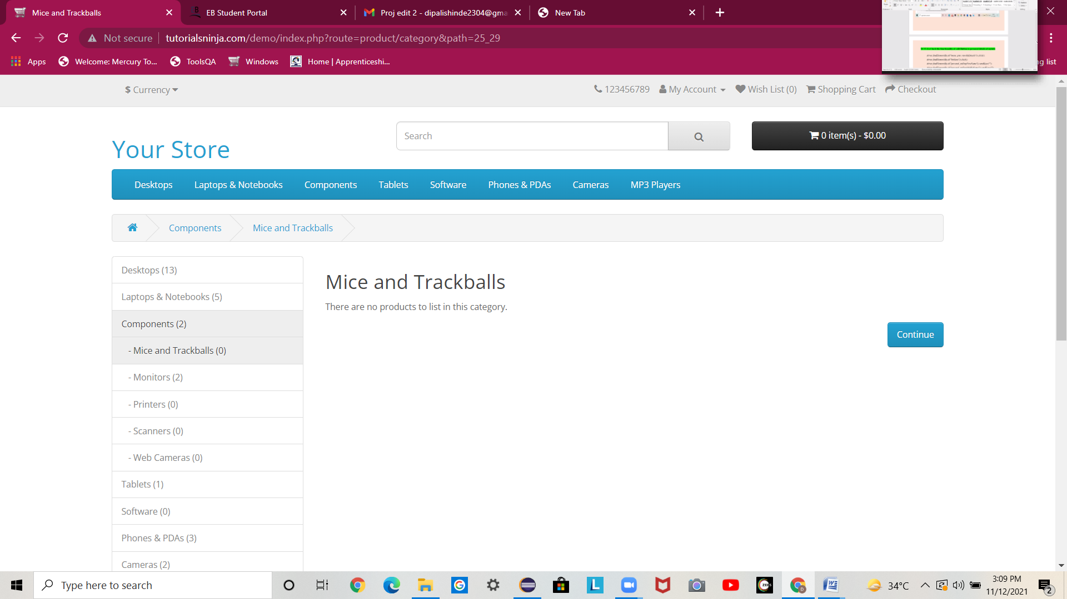

**TC24:- TO CHECK THE FUNCTIONALITY OF SEARCH BUTTON FOR COMPONENTS MAC AND TRACKBALL CONTINUE OPTION:-**

w.findElement(By.*linkText*("Continue")).click();

w.findElement(By.*xpath*(" //*[@id=\"content\"]/div/div/a")).click();



**TC25:- TO CHECK THE FUNCTIONALITY OF SEARCH BUTTON FOR COMPONENTS PRINTER OPTION:-**

//// Printers:-

w.findElement(By.*linkText*("Printers (0)")).click();

w.findElement(By.xpath("//*[@id=\"menu\"]/div[2]/ul/li[3]/div/div/ul/li[3]/a")).click();

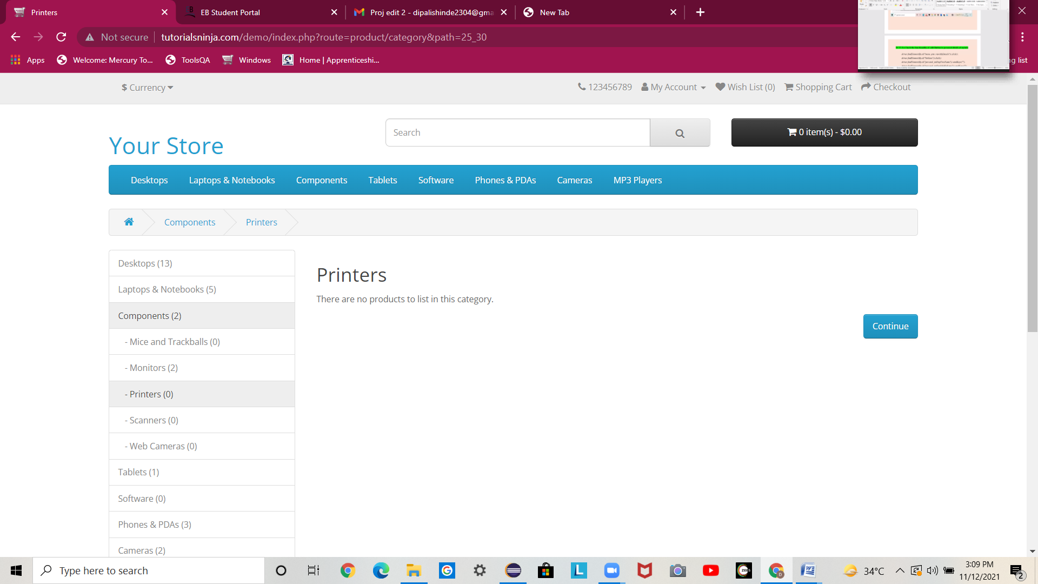

**TC26:-- TO CHECK THE FUNCTIONALITY OF SEARCH BUTTON FOR COMPONENTS PRINTER CONTINUE OPTION:-**

w.findElement(By.*linkText*("Continue")).click();

w.findElement(By.*xpath*(" //*[@id=\"content\"]/div/div/a")).click();



**TC27:- TO CHECK THE FUNCTIONALITY OF SEARCH BUTTON FOR COMPONENTS SCANNER OPTION:-**

w.findElement(By.*linkText*("Scanners (0)")).click();

w.findElement(By.*xpath*("//*[@id=\"menu\"]/div[2]/ul/li[3]/div/div/ul/li[4]/a")).click();

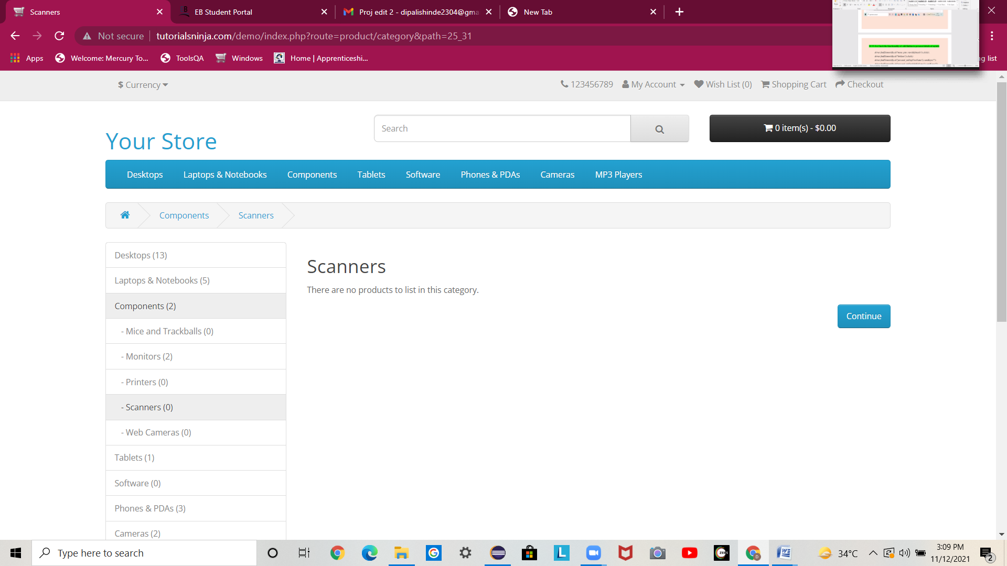

**TC28:- TO CHECK THE FUNCTIONALITY OF SEARCH BUTTON FOR COMPONENTS SCANNER CONTINUE OPTION:-**

w.findElement(By.*linkText*("Continue")).click();

w.findElement(By.*xpath*(" //*[@id=\"content\"]/div/div/a")).click();



**TC29:- TO CHECK THE FUNCTIONALITY OF SEARCH BUTTON FOR COMPONENTS WEBCAMERA OPTION:-**

w.findElement(By.*linkText*("Web Cameras (0)")).click();

w.findElement(By.*xpath*("//*[@id=\"menu\"]/div[2]/ul/li[3]/div/div/ul/li[5]/a")).click();

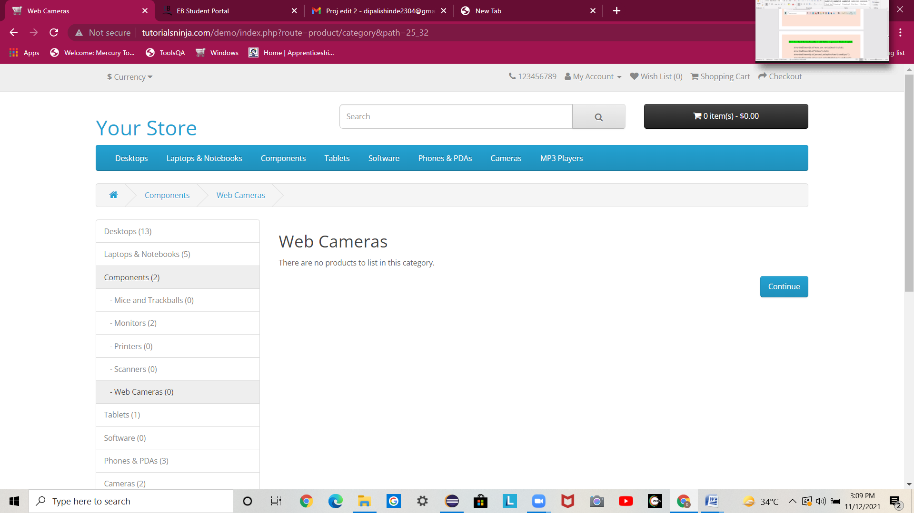

**TC30:- TO CHECK THE FUNCTIONALITY OF SEARCH BUTTON FOR COMPONENTS WEBCAMERA CONTINUE OPTION:-**

w.findElement(By.*linkText*("Continue")).click();

w.findElement(By.*xpath*(" //*[@id=\"content\"]/div/div/a")).click();



**TC31:- TO CHECK THE FUNCTIONALITY OF SEARCH BUTTON OF TABLET PAGE**

Selects5=newSelect(w.findElement(By.xpath("/htlm/div[2]/div[1]/div[1]/div[1]/div[2]/select[1]")));

s5.selectByVisibleText("Desktops");

w.findElement(By.id("description")).click();

w.findElement(By.id("button-search")).click();

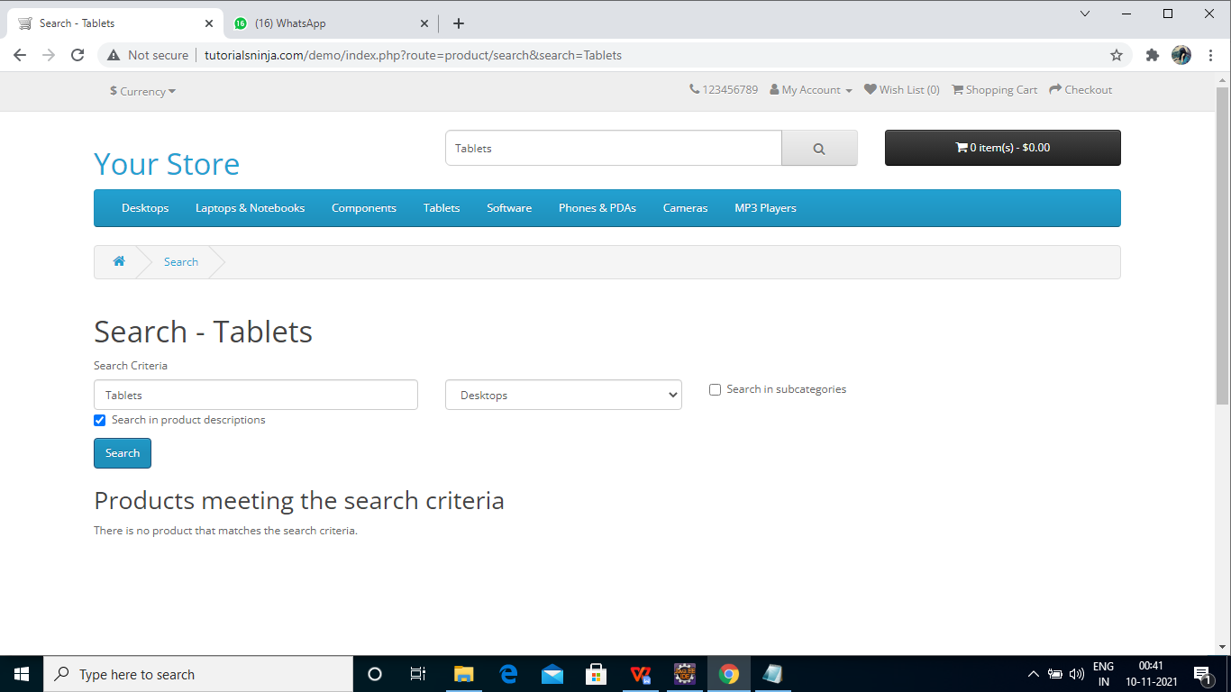

**TC32:-TO CHECK THE FUNCTIONALITY OF TABLET OF HOMEPAGE**

w.findElement(By.linkText("Tablets")).click();

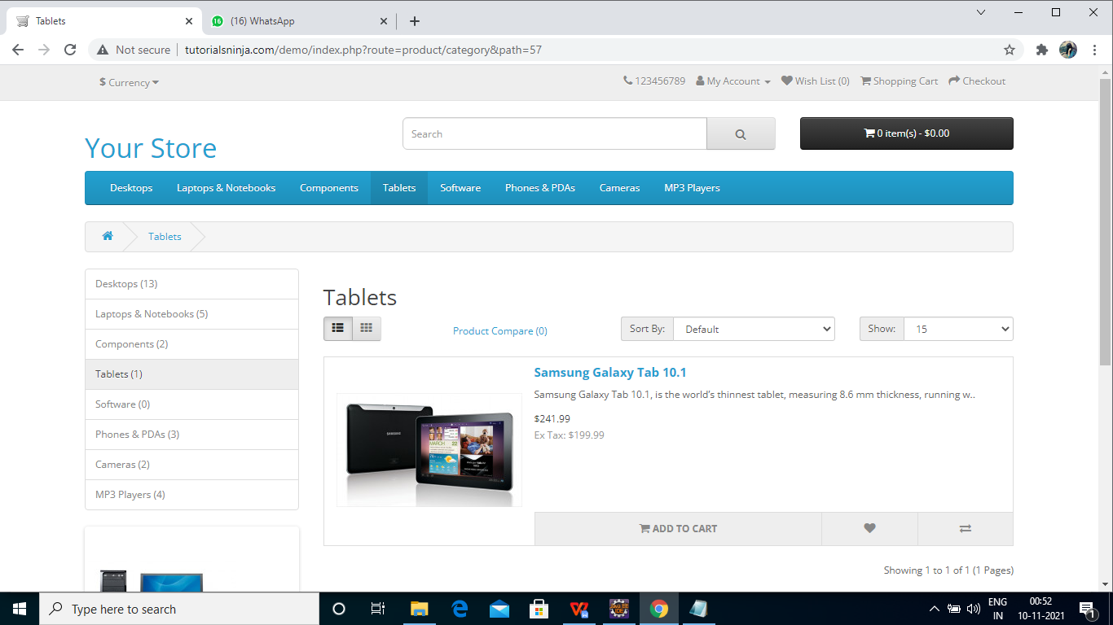

**TC33- TO CHECK THE FUNCTIONALITY OF ADD TO CART BUTTON OF TABLET PAGE**

w.findElement(By.xpath("/html[1]/body[1]/div[2]/div[1]/div[1]/

div[1]/div[1]/div[1]/button[2]")).click();

Thread.sleep(2000);

w.findElement(By.id("list-view")).click();

Select s1=new Select(w.findElement(By.id("input-sort")));

s1.selectByVisibleText("Name (Z - A)");

Select s2=new Select(w.findElement(By.id("input-limit")));

s2.selectByIndex(2);

w.findElement(By.xpath("//*[@id=\"content\"]/div[2]/div/div/

div[2]/div[2]/button[1]")).click();

Thread.sleep(2000);

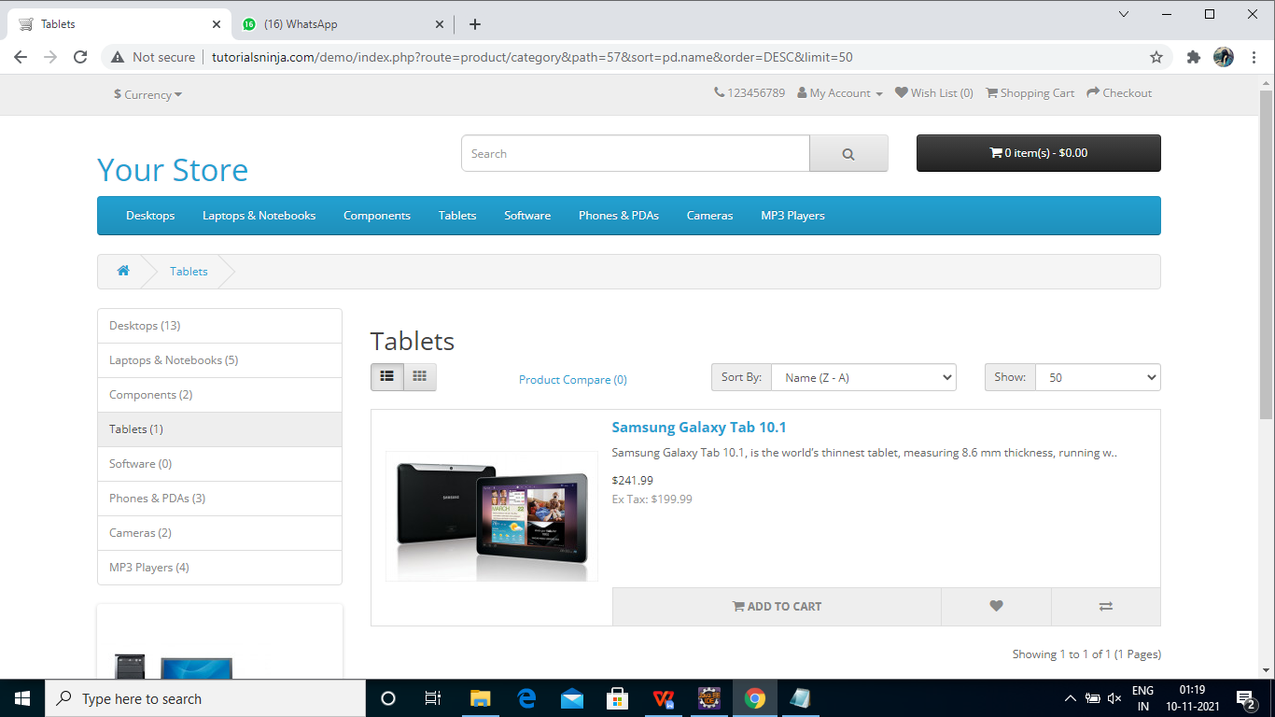

# 

**TC34:- TO CHECK THE FUNCTIONALITY OF ITEM BUTTON OF HOME PAGE**

Thread.sleep(2000);

w.findElement(By.xpath("//*[@id=\"cart\"]/button")).click();

Thread.sleep(2000);

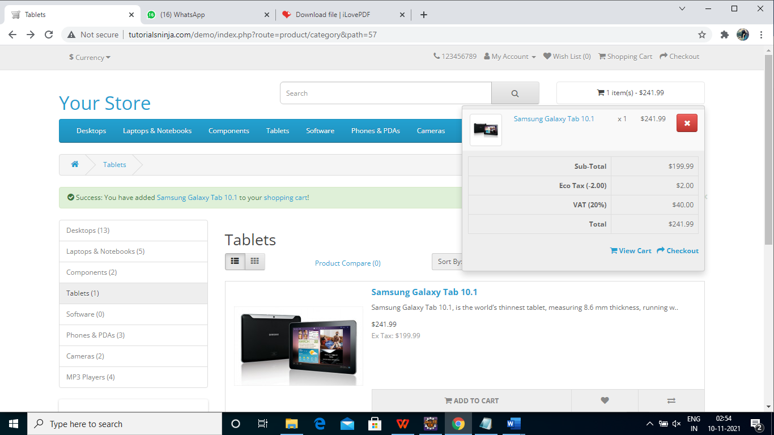

**TC35:- TO CHECK THE FUNCTIONALITY OF ADD OF WISH LIST BUTTON OF TABLETS PAGE:**

w.findElement(By.xpath("//*[@id=\"content\"]/div[2]/div/div/div[2]/div[2]/button[2

]")).click(); //add to wish List

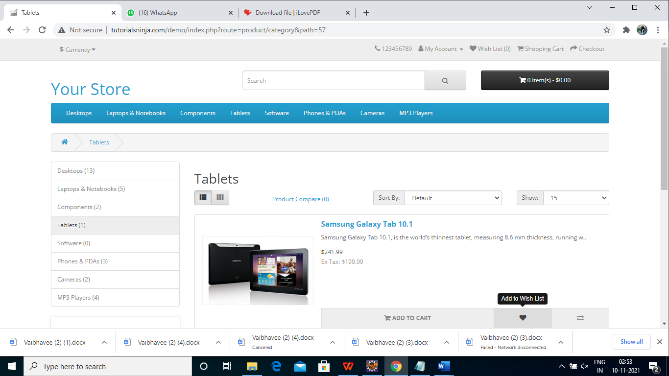

# 

**TC36:- TO CHECK THE FUNCTIONALITY OF ADD TO COMPARE BUTTON OF TABLET PAGE:**

w.findElement(By.xpath("//*[@id=\"content\"]/div[2]/div/div/div[2]/div[2]/button[3

]")).click(); //compare

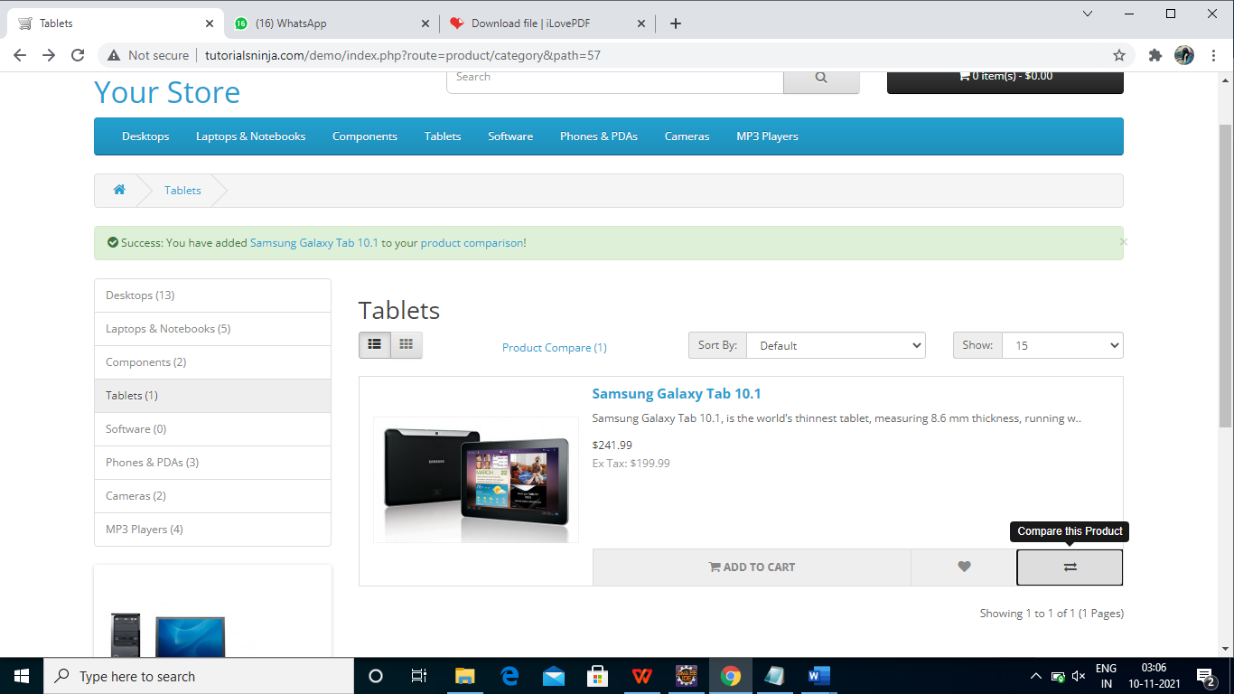

# 

**TC37:- TO CHECK THE FUNCTIONALITY OF PRODUCT COMPARISION BUTTON OF TABLETS PAGE:-**

w.findElement(By. id("compare-total")).click();

Thread.sleep(3000);

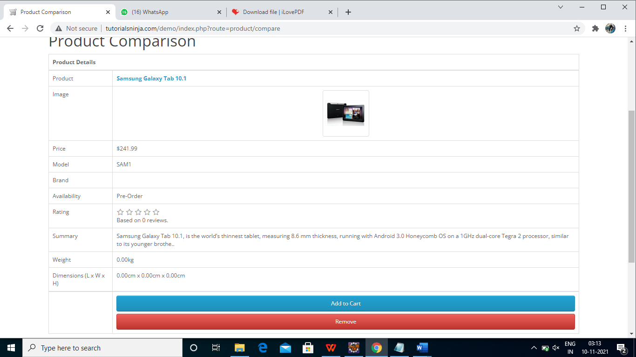

# 

**TC38:- TO CHECK THE FUNCTIONALITY OF REMOVE BUTTON OF COMPARISION PAGE:-**

w.fndElement(By.linkText("Remove")).click();

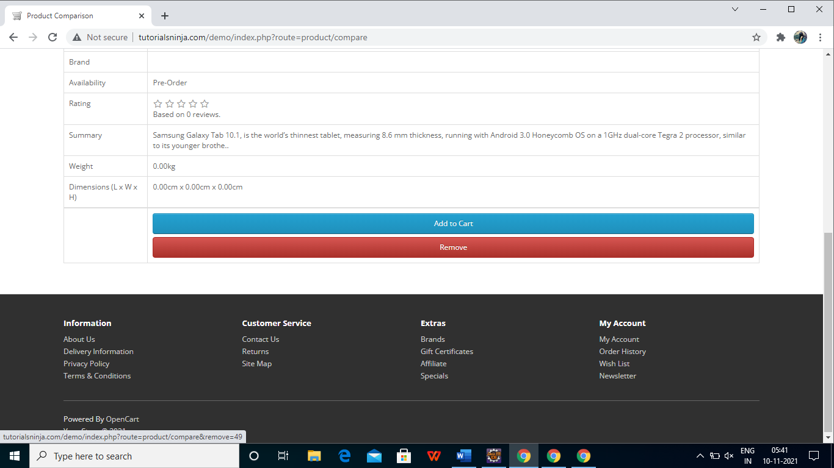

**TC39:-TO CHECK THE FUNCTIONALITY OF CONTINUE BUTTON OF PRODUCT COMPARISION**

w.findElement(By.xpath("//*[@id=\"content\"]/div/div/a")).click();



 